Buying a SIM card (Function: Create with Language)

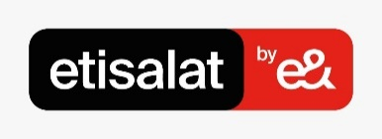
Context: You are planning for your study abroad journey in Cairo, Egypt. You seek information online about SIM cards and Telecommunication companies’ offers to choose from.

Task : Look online for information about SIM card plans, compare offers and make your choice then engage in a conversation with the teacher about your choice giving reasons for your preferences.

At-home preparation

Go to اتصالات | باقات ميجا الشهرية (etisalat.eg) and فليكس | ڤودافون مصر (vodafone.com.eg) and pick a package that you would like to buy. Summarize all the highlights that will make the SIM card package suitable for you. Make sure to include information about the company, name of the package, what’s included, price, and any other details you feel important. Bring to class to share.
Warm-up
إعلان سوبر نت من اتصالات - محمد سلام (youtube.com)
الشبكة بقت الدبل - اعلان ڤودافون × محمد صلاح (youtube.com)

Questions for class

(١) | ماذا شاهدتم في الفيديو؟
(٢) | أي إعلان تفضلون؟ لماذا؟

Helping Vocabulary

شهري(ة) | Monthly |  |  | باقة | Bundle
ببلاش | For free |  |  | نظام (ج.أنظمة) | Rate plan
شبكة (ج.شبكات) | Network |  |  | تحويل | Switch
ضِعف | Double |  |  | عيوب | Disadvantages
- باقات شهرية
SIM card monthly bundles. With your classmate, read these two excerpt from the two biggest telecommunication companies’ websites for monthly communication bundles. Compare and contrast using the chart given below.

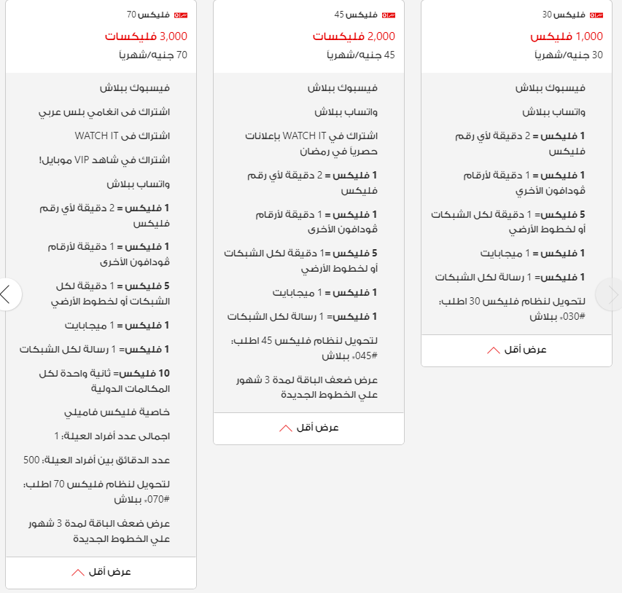

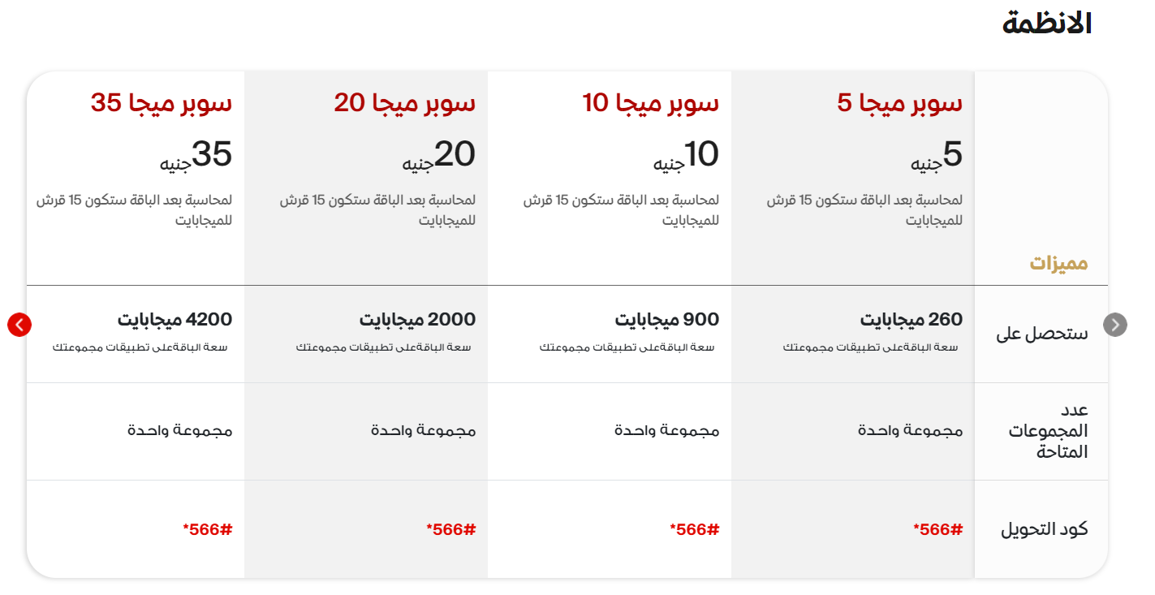

Draw a comparison among the three apartments using the following chart

 | فودافون | اتصالات
اسم الباقة
السعر
المميزات

Talk with your classmates about your preferences: which company would your buy your SIM card from? You can use the following prompts.

(١) | أفضل فوادافون لأنّ ..........................................
(٢) | لا أريد اتصالات بسبب ....................................
(3) | أفضل الباقة التي فيها .............................
(4) | لا أحب شراء باقة ليس فيها .............. لأنّ ....................
(5) | .....................................................................................................

- مع خدمة العملاء

Roleplay : with your classmate, engage in a conversation assuming the roles of a customer service agent and a potential client. Ask as many questions as possible to get a sense of what kind of bundles the agent has to offer. Switch groups to talk to another agent.

- مع الأستاذ

Reporting : Report to class comparing and contrasting the bundles you discussed and which one you decided to buy giving its description and providing justifications for your decision.

Apartment rental Task
Learning Standard | Communication
Function | Description and comparison
Duration | 50 minutes
Target Level | Second Year MSA
Objectives | At the end of this lesson, students will be able to:  - Describe and compare two communication bundles using vocabulary related to pricing and services.  - Interact and communicate preferences using appropriate grammar (e.g. Relative clauses, Cause)  - Successfully accomplish the task based on pros and cons of each telecommunication company.
Warm-up (10 minutes)
Video | Etisalat and Vodafone ads  Step 1. The teacher shows two videos: one from the company of Etisalat and one from Vodafone.  - Step 2. Students take notes and express opinions.  - Step 3. The teacher elicits more comments by pointing out some aspects from the videos.  - Step 4. Students discuss among each other what features they look for when looking for SIM card bundles.
Presentation (40 minutes)
- Reading & Vocab (5 minutes) | Students individually read excerpts from websites which will activate relevant vocabulary items about communication bundles. They extract information from both excerpts to compare and contrast using the given prompts.
- Interaction (15 minutes) learner-learner and teacher-facilitated | Students engage in sharing opinions as they compare and contrast and express preferences between the two companies. They then report to class and engage with teacher-facilitated prompts.
- Interaction (10 minutes)  (learner-learner) | Students engage in the role play task as outlined.
- Free Practice (10 minutes)  (learner-teacher) | Students engage with the teacher to present their experience in finding a suitable SIM bundle presenting reasons and justifications for their choices.
Evaluation (at home)
- Accuracy (writing): You just started your study abroad experience and bought your SIM card. Write a letter to the program director describing your experience with Telecommunication companies in Egypt expressing what you like or dislike about it. Try to compare them to the ones you have in the U.S.
- Communication (monologue): You want to share the knowledge you gained with future study abroad students. Record a tutorial video explaining to students what they should do to buy a SIM card in Egypt. Make sure to include information about companies, bundles, prices, benefits, etc.

Created by Amr Ahmad

