Mary McLachlan
Fulbright-Hays Group Project Abroad: Persianate World Lesson Plan

Road Maps: Around the World Adventure
Adventure Title: Silk Roads

In this 3-part adventure, you will work with a partner to build knowledge about the history of the Silk Roads and their continued relevance in today’s world. On your first Journey (Journey #1), you will explore three different locations along the Silk Roads. At each destination you will complete two tasks: an EXCURSION and an EXPLORATION. After you have completed all of your tasks and have experienced a sample journey, you will work with the same partner to create a journey (Journey #2) to be completed by your peers. You should design Journey #2 with the goal of expanding your classmates’ knowledge of the Silk Roads. For your last journey (Journey #3), you and your partner will expand your knowledge of the Silk Roads by completing a journey that was created by your peers. Once your have completed Journey #3, you have finished your adventure!

Journey #1: EXPLORE
Directions: Explore the Silk Roads by completing an Exploration and Excursion task at each destination.
Destination #1 | Xi’an, China
Destination #2 | Samarkand, UZB
Destination #3 | Yazd, Iran

Journey #2: CREATE
Directions: Challenge your knowledge of the Silk Roads by creating your own 3-stop adventure to be completed by your peers/classmates. Write the city and country name of each destination in the chart below.
Destination #1
Destination #2
Destination #3

Journey #3: EXPAND
Directions: Demonstrate your understanding of the Silk Roads by completing a peer-created Silk Road Adventure. Write the city and country names of the destinations you visit in the chart below.
Destination #1
Destination #2
Destination #3

Journey #1: EXPLORE

Introduction: Silk Roads Overview

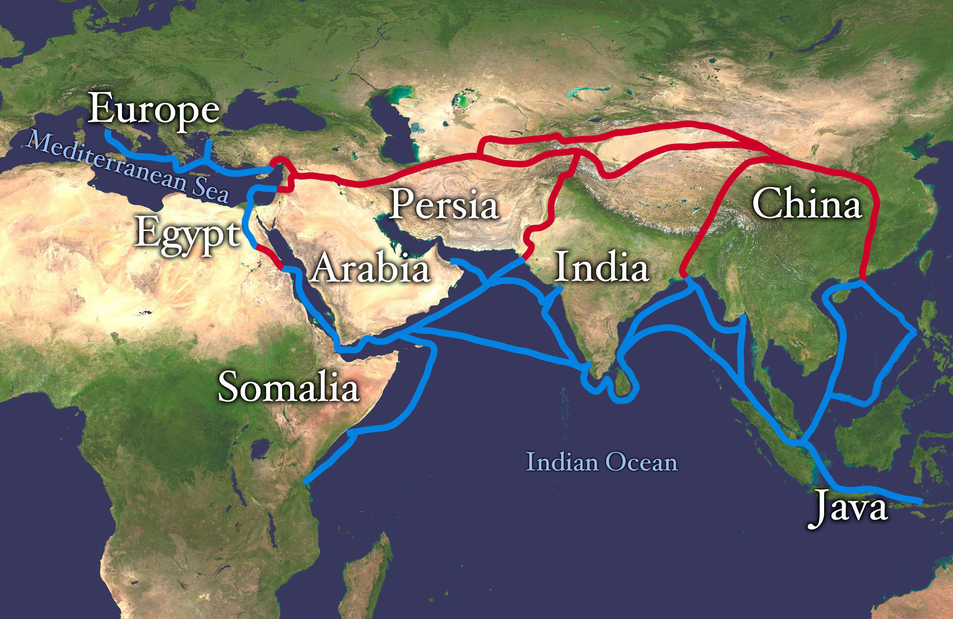

Before you begin your adventure, take some time to read this overview of the Silk Roads offered by Khan Academy and watch this CrashCourseHistory episode. Then, proceed to your first destination!

Destination #1: Xi’an, China

Exploration: Xi’an, China

China was a key contributor to the development of the Silk Roads trading systems and is the reason why we use the name ‘Silk Road’ to refer to this network of exchange. Learn more about the production and trade of silk and other goods by watching the following video and exploring the website below. Then, respond to the following questions:

- Describe where the city of Xi’an is located. What made this particular city an important site along the Silk Roads?
- What are the primary goods (fabrics, spices, dyes, etc.) associated with trade in this region?
- What cultural, linguistic or ideological exchanges were central to this region? (be specific!)

Excursion: Xi’an, China

Learn more about the ancient city of Xi’an by watching this video and conducting research on your own. Then, select one of the excursions to complete at this destination.

- Silk: Create an infographic that outlines the process of producing silk. Explain each step in the process and be sure to include information about why silk was (and still is) such a valued commodity.
- Xi’an fact sheet: Xi’an is considered to be the origin point of what would develop into the Silk Roads system of trade. Create a Xi’an ‘fact sheet’ that highlights the importance of this region in the development of the Silk Roads.
- Buddhism: During the 4th century, Xi’an flourished as a hub for Buddhist religion. Create an image gallery that visually traces the spread of Buddhism along the Silk Road. Be sure to label the location of each historic site as well as briefly describe its connection to Buddhism.

Destination #2: Samarkand, Uzbekistan

Exploration: Samarkand

Located in modern-day Uzbekistan, Samarkand is one of the most famous trading sites along the Silk Roads. Read the information provided on the UNESCO World Heritage website about Samarkand and watch the video below. Then, respond to the following questions about Samarkand’s history as part of the Silk Roads network of exchange.

- Describe where the city of Samarkand is located. What made this particular city an important site along the Silk Roads?
- What are the primary goods (fabrics, spices, dyes, etc.) associated with trade in this region?
- What cultural, linguistic or ideological exchanges were central to this region? (be specific!)

Excursion: Samarkand
Learn more about Samarkand and its contribution to the history of trade along the Silk Roads by exploring this website and researching more on your own. Then, select one of the following excursions to complete at this destination.

- Timurid architecture: Create an image gallery (at least 10 images) that highlights the most important aspects of Timurid architecture. Describe the key features in each image.
- Ulugh Bek: Create a mini-biography of the Islamic astronomer Ulugh Bek. Be sure to describe his contributions to the spread of scientific ideas and discoveries along the Silk Roads.

Destination #3: Yazd, Iran

Exploration: Yazd

Located in present-day Iran, Yazd has a rich history as part of the Silk Roads. Read the information provided on the UNESCO World Heritage website about Yazd and watch the video below about the Persian language. Then, respond to the following questions about Yazd’s history as part of the Silk Roads network of exchange.
- Describe where the city of Yazd is located. What made this particular city an important site along the Silk Roads?
- What are the primary goods (fabrics, spices, dyes, etc.) associated with trade in this region?
- What cultural, linguistic or ideological exchanges were central to this region? (be specific!)

Excursion: Yazd

Learn more about Yazd, the Persian language and the Persianate world by reading these article and researching more on your own. Then, select one of the following excursions to complete at this destination.

- Zoroastrianism: Write a brief (1-2 paragraph) description of Zoroastrian religion. Outline key beliefs, customs and practices as well as its historical connections to the Silk Roads.
- Persian language: Create a map that outlines the spread of Persian language and culture along the Silk Roads. Identify at least 5 languages that have borrowed or adopted Persian words thanks to its importance in Silk Road exchange.

