Task: your job in the future.
Learning Standard | Communication
Function | Description
Duration | 50 minutes
Target Level | 2nd grade Elementary school
Objectives | At the end of this lesson, students will be able to:  - Describe the job they like to be in the future using vocabulary related to jobs.  - Interact and communicate preferences using appropriate grammar (e.g. kana waakhwateha كان واخواتها )  - Successfully accomplish the task based on pros of each job.
Warm-up (10 minutes)
Task | What would you like to be in the future ….? Why? Conduct a survey.  - Step 1. Students conduct a survey in class. They must ask one or two students about their dream’s job in the future and the reasons why they choose it and what they should do to achieve their goals.  - Step 2. Students report their findings.  Bonus activity: students report the students who like to be. For example, they can report using my partner like to be a doctor and give the reasons.  Students may also express reason as to why they like to be this in the futre.  - Step 3. Use verb اصبح like to be to introduce new vocabulary.
Presentation (40 minutes)
- Grammar & Vocab (10 minutes) | Activate relevant vocabulary items about their dream jobs (e.g. Helping the community, preferences, rewards they earn).
- Interaction (20 minutes)  (teacher-facilitated, guided practice) | The teacher and the student engage in the dream job task as outlined in the task description.
- Free Practice (10 minutes)  (learner-learner) | Students engage in the dream job task as modeled by the teacher.
Evaluation (at home)
- Accuracy (writing): You are 2nd grade student and you are writing a letter to your parents to tell them about your dream job in the future, explaining why you choose this job, what do you need to achieve your goal, taking their opinion about it, and how they can help you to achieve the goal.
- Communication (monologue): Tell us about your dream job, why you prefer this job,
- What are the benefit you may earn , what the most thing you like about this job, which subject you need to focus to help you to achieve the goal.

Supplemental material:
- Verb to be in the future
- Jobs

I would like to be | Study | Imam at masjed | Engineer
help | Speak | Bus driver | Teacher
Cook | Cure | cook | Basketball player
Teach | get | Dentist | doctor

- Survey:

Student name | The job | why? | Subject to focus
 | doctor | Help people | Science…
 | teacher | Love kids | Language art…
 | dentist | Help people to have healthy teeth. | …..
 | player | Love playing physical sports. | PE

========

ورقة عمل:
الاعمال والمهن

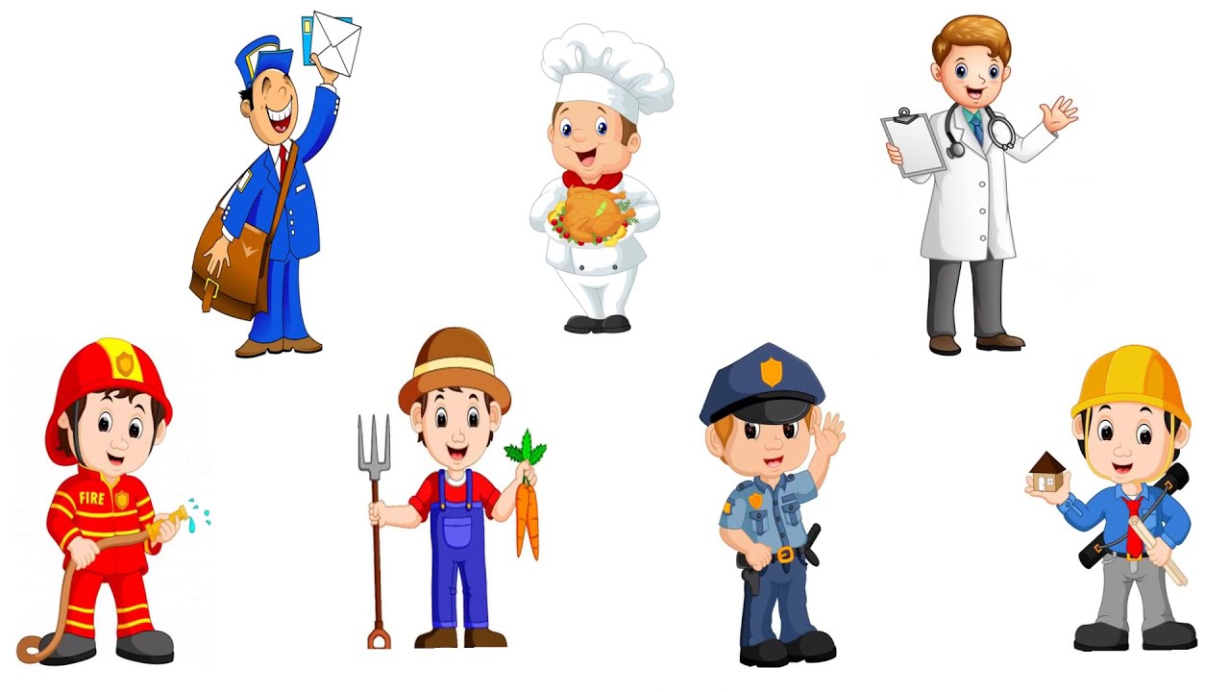
أساعد المرضى واصف لهم الدواء  لابد ان اذاكر جيدا خاصة مادة العلوم | طبيب
احب ان اعمل في المطبخ واعد طعاما لذيذا  اطعم الناس اشهى الماكولات ليستمعوا بطعامي اللذيذ | طباخ
اصل الى بيوت الناس لاقدم لهم الرسائل المهمة  احب ان اساعد المجتمع بايصال الاوراق الهامة لاصحابها | ساعي البريد
اهوى الفن والتصميم  احب ان اصمم بيوت جميلة للناس | مهندس معمارى
احافظ على ضبط الامن في المدينة  احب ان اساعد المجتمع على اتباع القوانين | رجل الشرطة
احب ان ازرع الفواكه والخضروات  احب ان ياكل الناس فواكه وخضروات لذيذة | المزارع
اساعد على اطفاء النار  احب ان انقذ الناس من الحوادث | رجل الاطفاء

