Historically Seasoned: Spices & Herbs of Uzbekistan
Mickey Marsee, PhD
Chandler-Gilbert Community College
Mickey.marsee@cgc.edu

Designed for freshman composition course at community college. These plan offers direction for 3 class meetings (75 minutes long) with homework. The final project, a group researched and written multimedia essay, may include additional days in the overall lesson (2-3 class periods for research, drafting, and revising).

Learning Objectives
At the end of this lesson, students should be able to
- Identify specific spices used in Uzbek cooking and commerce
- Identify and analyze the role spices play in modern and historical Uzbekistan
- Describe the sensory experience of Uzbek
- spices
- Research and synthesize information on a single spice and explains its role in Uzbek history, culture, and cooking (including economic values, sustainability, etc.)
- Report on a researched spice using multiple media
Materials needed

Sample pack from a Bazaar in Uzbekistan—these spices are also available in most U.S. supermarkets. A few of these are spice mixes unique to each bazaar stand owner; the mixes are for specific foods. For the purposes of this assignment, only use single spice items.

Place spice/herb in small bags or vials. Label with numbers so students do not know the name. That will be revealed to them later.
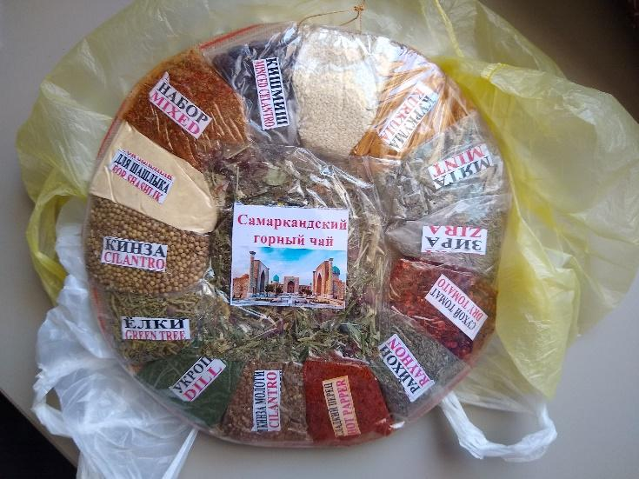
- Cilantro seeds
- Ground cilantro
- Dill
- Cumin
- Mint
- Paprika
- Cayenne
- Cinnamon
- Barberries
- Raikhon (basil- may need international market)
- Zhambyl (thyme)

Lesson Questions
- To what extent do spices and herbs connect to the trade history and culture of Uzbekistan?
- How does an olfactory experience transport us beyond a simple history lesson?
- What can a spice inform us or reveal about a place’s history? What can we learn from it?
- What surprising aspect of Uzbek culture/history does spice X reveal? (culturally, historically, economically, sustainability, environmentally)

Day 1- What’s that smell? Role of smell in History

Objectives:
Access prior knowledge of smell observation and connection to memory
Identify role of smell in culture/memory
Discuss and evaluate the concept of smell in culture
- Slides 1-2: Group activity: Rank these Aromas
- Slides 5-8: Role of the sense of smell in history, culture and everyday life
- Slide 9: Think/Pair/Share: Reflecting on the idea of smell in history
- Slide 10: Homework – Reading Response to the question: What role does smell play in understanding history/culture?

Day 2: Experiencing the smell of Uzbekistan

Objectives:
Review role of smell in understanding or accessing culture
Describe a smell experience
Identify key spices and herbs of Uzbekistan
Introduce role of spices in historical trade in Central Asia/Silk Road

Key Questions:
- How did spices and the spice trade contribute to the interactions of people across Central Asia and the emergence of the Silk Roads?
- How did people’s desire for fragrant goods like spices and incense help connect people in Uzbekistan to other parts of the world?

Additional resources:
- Online Silk Road Map - can be projected or screen-shared to show students the multiple routes making up the Silk Roads: http://www.chinatourguide.com/china_photos/Silk_Road/Maps/silk_road_entire_map.jpg
- Interactive Silk Road Map, could be used as starting point for extension projects https://en.unesco.org/silkroad/silkroad-interactive-map
- National Geographic Silk Road on Foot Article - interactive, lots of pictures
https://www.nationalgeographic.org/interactive/foot-path-silk-road/
- Additional Reading on using the sense of smell in teaching and learning: Hacking Senses to Boost Learning

- Slides 12-16: Historical context of spices/herbs
- Slide 17: Background on Uzbekistan
- Slide 18 (hidden) – 19: Smell experiences with spices from Uzbekistan
- Slide 20-21: Spices and the spice bazaar in Uzbekistan
  - Guiding question in reflection time: So how did these products and smells, and others like them, help shape history?

- Slide 22: Homework—
- Using your notes from the class smelling experience, write two descriptive paragraphs: one for your favorite smell, and one for your least favorite.
- Begin preparing to research with your group, one spice from Uzbekistan by reading the articles below on the spice trade along the silk road. They lay a basic foundation.
- Write a one paragraph summary synthesizing what you learned about the spice trade from the articles.

Day 3: Assigning the Spice Multimedia Essay project

Objectives:
Identify for group project one of the spices from Uzbekistan
Research history and use of the spice/herb
Synthesize information into multimedia essay

(Note: So this project obviously will take more than a day to complete; instructors can assign however many days they deem appropriate for research, drafting, workshopping and submission. )

- Slide 24: Review Questions from previous readings and homework
- How does an olfactory/ smell experience transport us in a history lesson or culture?
- What can a spice or the spice trade inform us or reveal to us a place’s history?
- To what extent do spices or the spice trade connect to the history and/or culture of Central Asia or Uzbekistan?
- Slide 25: Assignment
For this assignment, in groups of 3-4, you will create a multimedia essay using primary and secondary research to respond to the question: What surprising aspect of Uzbekistan history and culture does spice X reveal? (Spice X is the spice/herb your group selects from the smell experience)

Students should use earlier questions to help guide their inquiry:
- To what extent do spices and herbs connect to the trade history and culture of Uzbekistan?
- How does an olfactory experience transport us beyond a simple history lesson?
- What can a spice inform us or reveal about a place’s history? What can we learn from it?
- What surprising aspect of Uzbek culture/history does spice X reveal? (culturally, historically, economically, sustainability, environmentally)

Assignment requirements: (***Note: This assignment can take many forms: a report, a traditional essay, a wikipage, a podcast, a video. Part of scaffolding is to include their earlier work in describing the spice/herb in class exercise and synthesizing discussion of the role spices play overall.)

- Focus on one spice and on Uzbekistan
- Incorporate a minimum of 3 media support pieces
- Text should run approximately 750 – 1,000 words and include information about and description of the spice, its history, and its role in historic and contemporary Uzbek culture (can include economic aspects, culinary use, sustainability, globalization, etc)

Bibliography

Ancient Sumeria To Chipotle Tacos, Cumin Has Spiced Up The World: https://www.npr.org/sections/thesalt/2015/03/11/392317352/is-cumin-the-most-globalized-spice-in-the-world
Bembibre, C., Strlič, M. Smell of heritage: a framework for the identification, analysis and archival of historic odours. Herit Sci 5, 2 (2017). https://doi.org/10.1186/s40494-016-0114-1
Breaking News English Lesson: Historic Smells. https://breakingnewsenglish.com/2011/201119-historic-smells.html
Cook, S. (2018). Biodiversity and the future of farming. In The spice of life: the fundamental role of diversity on the farm and on the plate (pp. 10–18). International Institute for Environment and Development. http://www.jstor.org/stable/resrep16590.7

EastAsiaHK. (2020, June 9). Uzbekistan - Exclusive Performance of Doira va Raqs by Tara Pandeya and Abbos Kosimov [Video]. YouTube. https://youtu.be/-Sfdw3GjgFU
Eden, Caroline. (2021).Samarkand: Recipes & Stories from Central Asia & The Caucasus
Herz, R.S. (2002, 11 Nov). Do scents affect people's moods or work performance? Scientific American. https://www.scientificamerican.com/article/do-scents-affect-peoples/
Jenner, M.S.R. (2011). Follow Your Nose? Smell, Smelling, and Their Histories. The American Historical Review, 116(2), 335–351. http://www.jstor.org/stable/23307699
Khojimatov, O.K., et al. (2015). Some wild growing plants in traditional foods of Uzbekistan. Journal of Ethnic Foods, Vol. 2, Issue 1, Pages 25-28, https://doi.org/10.1016/j.jef.2015.02.005
Loewe, M. (1971). Spices and Silk: Aspects of World Trade in the First Seven Centuries of the Christian Era. Journal of the Royal Asiatic Society of Great Britain and Ireland, 2, 166–179. http://www.jstor.org/stable/25203290
MM Channel. (2021, Jan 11). The spice market at Bukhara, Uzbekistan [Video]. YouTube. https://youtube.com/clip/Ugkx-nMe1YT7K2b9LL5IQDTrIabqijIaMsnd
Patterson, Daniel. (2016, 26 Aug) “Spices, culture and the value of cuisine.” Medium. https://medium.com/@dcpatterson/spices-culture-and-the-value-of-cuisine-8581bebb3d3d
Ray, P. S. (2016). “Silk road economic belt and the 21st century maritime silk road: Effect on global supply chains and maritime connectivity.”Proceedings of the Indian History Congress, 77, 828–834. https://www.jstor.org/stable/26552712
Resource about a smell sensory project in Europe: https://odeuropa.eu/ with an excellent bibliography at: https://odeuropa.eu/publications/
Spengler III, R.N. (2020) The Silk Road Origins of the Foods We Eat. Central Asian Arecheobiology. https://robertnspengler.com/fruit-from-the-sands-the-silk-road-origins-of-the-foods-we-eat/

Michelle Krell Kydd, creator of Smell and Tell programming for educators, provides suggestions for how to create a scent kit: Visit her blog for more ideas about scent and smell: https://glasspetalsmoke.blogspot.com/
Adapted from “The Scent of History: How the Spice Trade Connected the World,” created by Colin Roberts and Darin Stockdill, Center for Education Design, Evaluation, and Research, University of Michigan School of Education (2021).
Ibid

